

First Conference Announcement & Call for Posters

Jokkmokk Winter Conference 2010

1 February - 4 February

Changing Climates: the new political and environmental reality for Northern Communities

Jokkmokk Winter Conference is an annual International Climate Forum at the Arctic Circle in Sweden for Students, Researchers, Young Decision Makers and Opinion Builders.

Jokkmokk Winter Conference is initiated and organized by the Municipality of Jokkmokk in cooperation with the University of the Arctic, Rovaniemi, the Association of Polar Early Career Scientists (APECS) at the University of Tromsö, the Luleå University of Technology, the Vaartoe Centre for Sami Research at Umeå University and the Sami Education Centre in Jokkmokk.

Jokkmokk Winter Conference provides a forum where young professionals and students from across political and disciplinary boundaries can:
- Get up-to-date information about climate change in the North and discuss impacts of climate change on the circumarctic and the global connections.
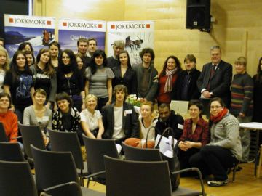
- Learn from and establish mentor
relationships with policy makers and
sustainable development professionals.
- Create working groups to carry forward
ideas and action items generated from
the discussions and form new collaborations
and partnerships.
- Create opportunities for experience
exchange and develop new strategies
and initiatives for the North.

MAIN ISSUES 2010
- Which impacts will the next international Climate Treaty, to be decided in December 2009 in Copenhagen, have on future development in the North?
- How does climate change influence the traditional life style of the Sámi people?
- Chances and risks of exploring (renewable) energy resources in the North and military threats resulting from a melting Arctic

CALL FOR POSTERS
One afternoon of the conference is designed to showcase projects and activities. This is a perfect opportunity to meet with other young researchers, participating climate experts and other mentors. You can present your own activities, ask any question to the experts and mentors as well as get support and tips for your career and on your presentation. In addition you can easily create new networks for the future.

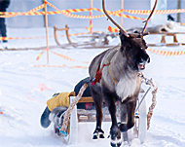
HOW TO APPLY
Interested students and researchers can apply by
going to
www.winterconference.se

Jokkmokk Winter Conference is coordinated
with the international Jokkmokk Winter Market.
A legendary impressive traditional Sami event
since 1605.
Take part in the famous Sami Winter Market and
explore one of the main centres of Sami tradition
in Lapland!
www.jokkmokksmarknad.se


